Activity 5.6: Infection risk app
Use the algorithm below to help you program an app that the villagers in Kitanga District can download onto their mobile phones to calculate their infection risk.
Use a programming language of your choice to program the app. The app must be efficiently coded, intuitive to use, attractive to look at and, above all else, accurate.
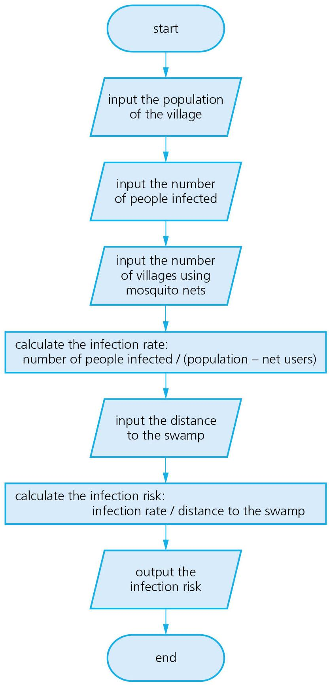
Test your app using the following data:

Population of village | 400
Number of clinics | 2
Mosquito net users | 26
Number of people infected | 20
Infection rate | 0.05
Number of deaths | 6
Distance to swamp (km) | 1
Infection risk | 0.05

